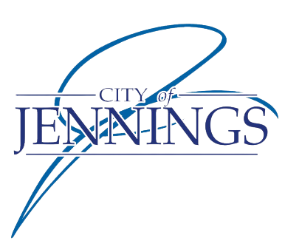

NOTICE OF PUBLIC HEARING

The City of Jennings will hold a public hearing on Monday, June 24th at 7:00pm at Jennings City Hall and via Zoom. The purpose of the hearing is to hear comments in favor of, or opposed to, the following:

- Petition for Site Development Plan – to construct a Bank of America at 8003 West Florissant Ave in the South Gateway commercial zoning district under NAICS code 521110. Petitioner: Andrew Wehler

Jennings City Hall
2120 Hord Avenue
Jennings, MO 63136

PUBLIC COMMENTS ARE INVITED ON THE ABOVE REQUESTS.

For accommodation due to disability, please call City Hall at 314-388-1164, or Relay Missouri (TDD) at 1-800-735-2460, 72 hours in advance of the meeting.

By order of the City Council of the City of Jennings, MO

Shaquan Brown, City Clerk

